Communication With Volante :
----------------------------------------------------------------------------------------------------------
Communication With EPFO :
SOPTC/E/2026/04073 First Grivenace With EPFO
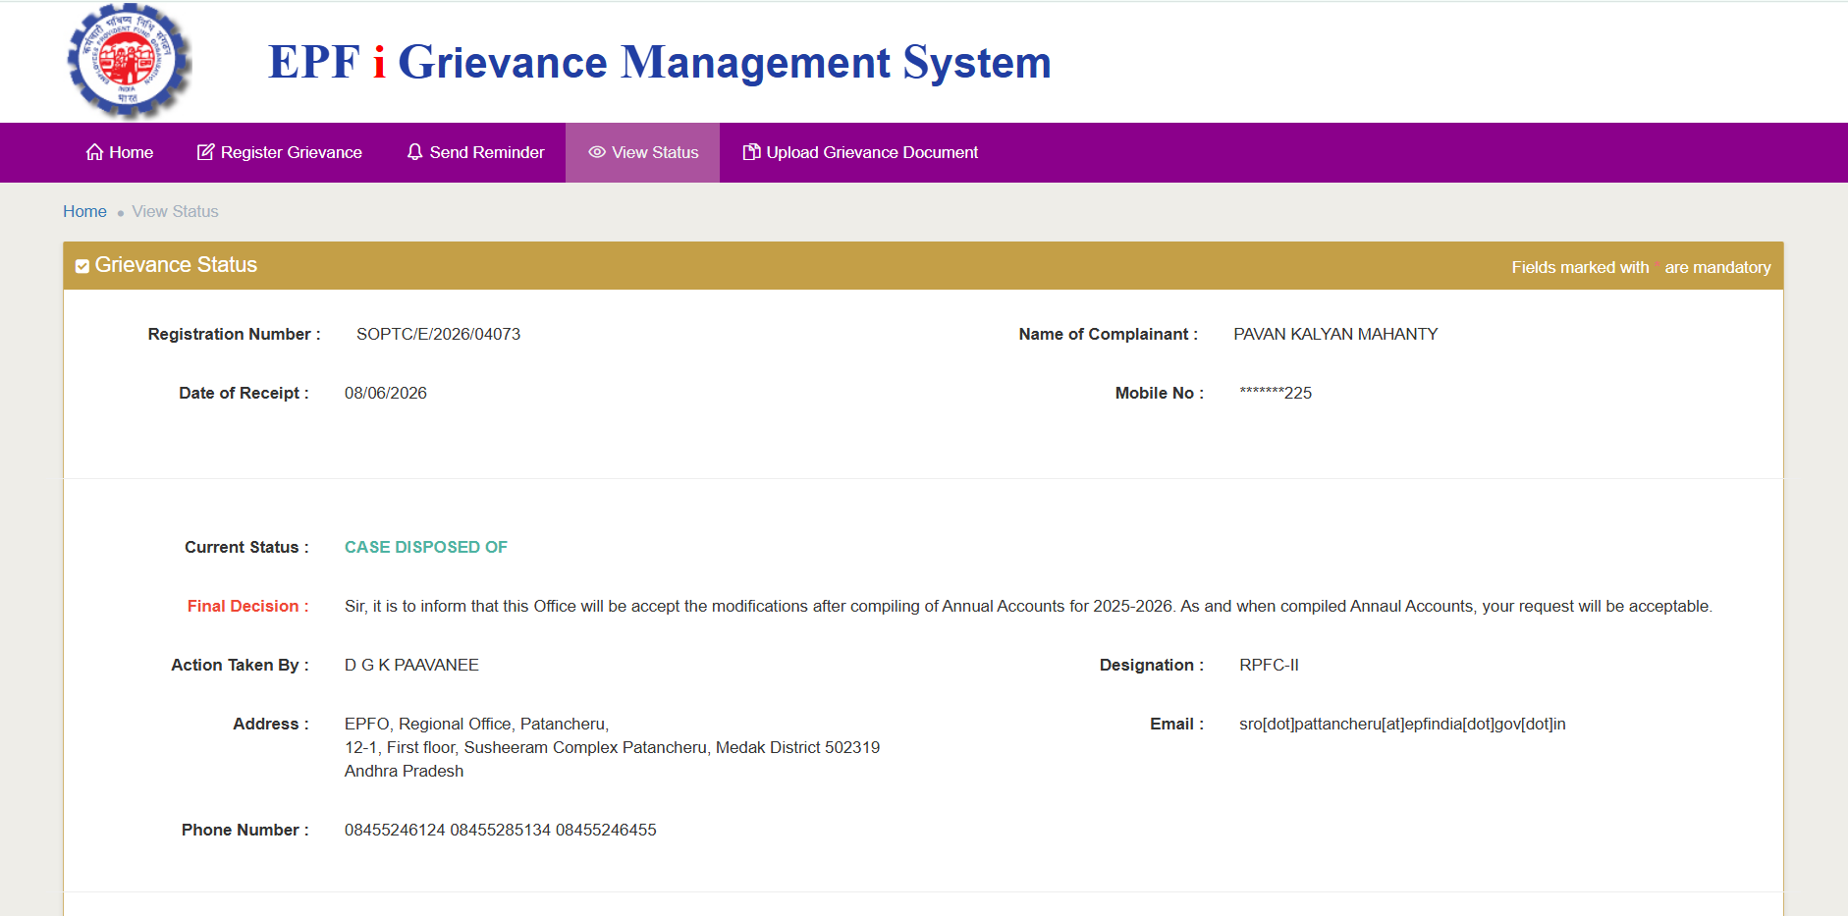

SOPTC/E/2026/06877 Second Grivenace With EPFO
DESCRIPTION:
Personal and PF Details: Name Pavan Kalyan Mahanty, UAN 101985917703, Member ID APHYD21088260000011386, Establishment Volante Technologies India Private Limited, Establishment Code APHYD2108826000, Previous Grievance Ref SOPTC/E/2026/04073.
Background and Issue:
My online EPF transfer request Form 13 was rejected due to missing EPS contributions from March 2024 to September 2025. My former employer Volante Technologies India Pvt Ltd submitted the formal reallocation letter Form 3A with Inward No 40502 to Regional PF Office Patancheru on 20/04/2026. The employer requested reallocation of the statutory portion from EPF head to EPS head.
Current Status:
I previously raised grievance SOPTC/E/2026/04073 and was informed that the update would be processed with annual financial year reconciliation. However it has been over 2 months and the reallocation is still not updated in my passbook. This is blocking my PF transfer.
Requested Relief:
Kindly expedite the manual ledger adjustment and passbook update for Member ID APHYD21088260000011386 based on employer submission dated 20/04/2026. Update my EPS pensionable service and contribution records to enable successful PF transfer.
Thanks
Pavan Kalyan Mahanty,
Mobile 7337010225
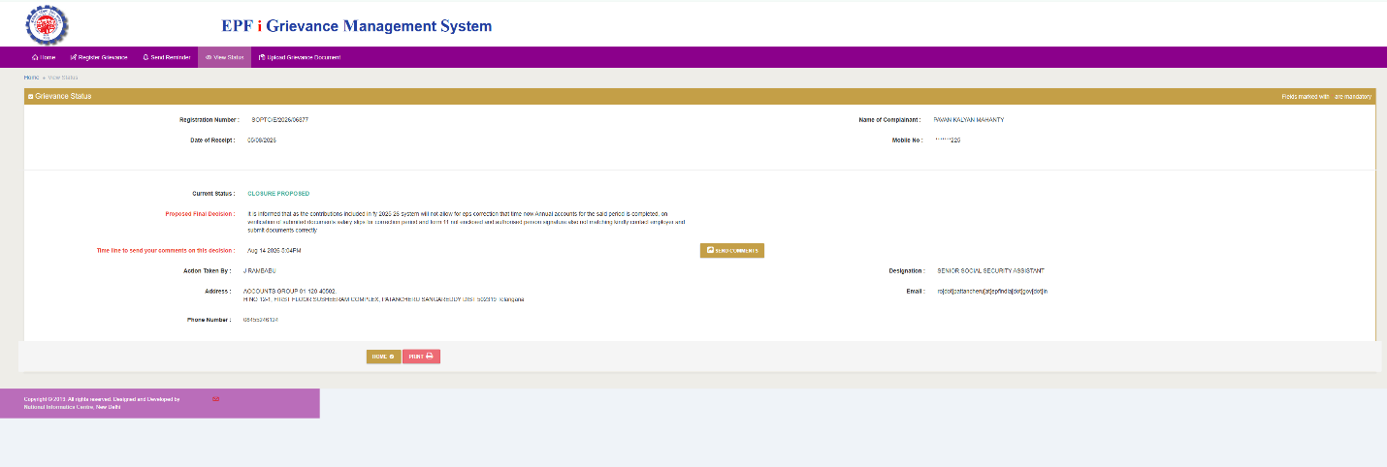
Respected Sir/Madam,
Regarding Member ID APHYD21088260000011386, please note that my former employer Volante Technologies India Pvt Ltd submitted a consolidated bulk application for multiple employees under Inward Reference No. 40502 on 20/04/2026.
The salary slips, Form 11, and supporting documents for all affected employees were submitted together as a single package with that main reference file.
Kindly request you to please re-verify the main file under Inward No. 40502 at Patancheru office where these attachments are enclosed.
Pavan Kalyan Mahanty,
Mobile 7337010225
